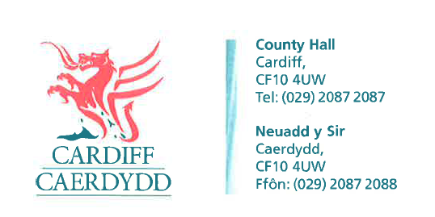
FOI18190
Thank you for your request under the Freedom of Information Act 2000 about Allotments received on 27/07/2022.
Request:
This request relates to Pontcanna Permanent allotments. I would like the information held from the past 10 years where relevant.
1. When was the last time each plot was measured? Can any documents(this includes emails) held regarding measuring and marking plots be supplied.
Response: The City of Cardiff Council does not hold this information therefore under Section 17 of the Freedom of Information Act 2000 this acts as a refusal notice.
Under Section 16 of the Freedom of Information Act 2000 we have a duty to advise and assist our customers.
We do not hold records of when each plot at Pontcanna Permanent Allotments was re-measured – specific details of plot sizes were provided to the Council in 2001 when the Council took back responsibility for the management of the Allotment Service from Cardiff and District Allotment Holders Ltd who were responsible for managing allotments between 1995 and 2000.
2. Copy of any protocol/guidance for measuring plots (or equivalent documentation).
Response: Plot remeasurements are carried out either by Council officers or by site committee volunteers. The size of a plot is measured up to the centre of the pathway either side of the plot.
The formula below is how the size of a plot is calculated:
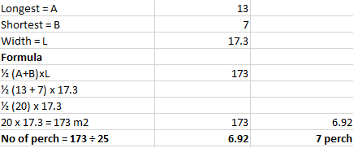

3. How many complaints have been made regarding the allotment officer for Cardiff council & what are the subject matters of these complaints? If this is deemed personal data, can you please supply me with the information but for the allotment officer's department.
Response: We have estimated that the cost of complying with your request will exceed £450. We have made this calculation in accordance with Regulation 4 of the Freedom of Information and Data Protection (Appropriate Limits and Fees) Regulations 2004.
We don’t record complaints under the category of alloment officer, complaints of this nature would fall under ‘parks’. In order for us to find this information we would have to look through each individual complaint for parks.
Under the request we have identified 290 complaints for parks. After conducting a sample search of folders and mailboxes we have established that it would take approximately 10 minutes per search to answer your request per case. Therefore we calculate it would take approximately 48 hours to accomplish this task.
Under Section 12 of the Freedom of Information Act we are not obliged to comply with a request for information if we estimate that the cost of complying with the request would exceed £450.
This part of the request is therefore refused under section 17(5) of the Act.
4. What is the service level agreement for the Parks department in Cardiff council? What is the time frame in which customer enquiries' should be responded to?
Response: The attached document (Attachment 1) explains the policy for Comments, Complaints and Compliments – formal acknowledgement in 5 working days, full response in 20 working days.
If you have any queries or concerns, please do not hesitate to contact us.
Please remember to quote the reference number above in any future communications.

